Parentcraft Sessions
AUGUST
Monday | Tuesday | Wednesday | Thursday | Friday | Saturday | Sunday
31st  Basic Life Support | 1st  Parent and Family Coffee Morning | 2nd  Participating in Ward Rounds | 3rd  Breastfeeding | 4th  Coping With Stress | 5th  Bottle-Feeding and Making up Feeds | 6th  Making Memories
7th  Parent and Family Coffee Morning | 8th  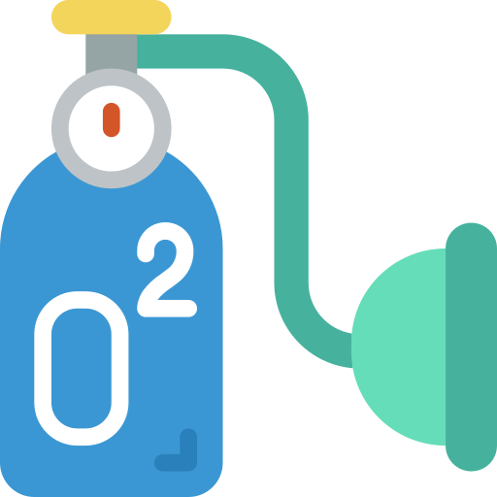  Babies and Oxygen | 9th  Bathing | 10th  Expressing Milk | 11th  Supporting Baby’s Development | 12th  Getting Ready for Home | 13th  Basic Life Support
14th  Comforting your Baby | 15th  Expressing Milk | 16th  Parent and Family Coffee Morning | 17th  Basic Life Support | 18th  Bathing | 19th  Breastfeeding | 20th  Bottle-Feeding and Making up Feeds
21st  Supporting Baby’s Development | 22nd  Getting Ready for Home | 23rd  Participating in Ward Rounds | 24th  Parent and Family Coffee Morning | 25th  Babies and Oxygen | 26th  Making Memories | 27th  Coping With Stress
28th  Expressing Milk | 29th  Basic Life Support | 30th  Coping With Stress | 31st  Comforting your Baby | 1st  Parent and Family Coffee Morning | 2nd  Bottle-Feeding and Making up Feeds | 3rd  Breastfeeding

This timetable can be adapted monthly to meet the needs of the families and availability of staff.
Each session will require a planned training programme.

